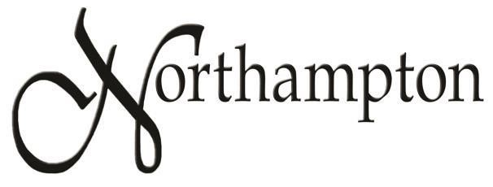

Homeowner’s Association

2022 Annual Meeting Minutes

Minutes of the annual meeting of the Northampton HOA, held Tuesday, November 7, 2022 at the Robin Ridge Clubhouse, 2325 NW 151st St, Edmond, Oklahoma.
There were 11 home owners or co-owners present, representing 8 homes. Members of the Board of Directors present were: President Chris Barkett, Vice President Maury Morris, and Board Members Sandi Barkett and Mike Prykryl. A list of all attendees is attached.
HOA President Chris Barkett called the meeting to order at 7:00 pm. He showed the notice of the meeting and stated that it had been mailed by first class mail to all owners of record. He asked if everyone present had received a notice and they all had. There were no proxies to be certified.

President Barkett reviewed the major happenings of 2022:
- The sign at the north side main entrance was replaced after it fell out and broke. The brick walls of the entrance signs were repaired to restore structural integrity. This was quite expensive.
- The fence along Pennsylvania was power washed and re-stained.
- The lights at both water features were repaired and replaced. The electrical outlet at the second water feature was upgraded.
- Heads of the main sprinkler system were repaired and we expanded the drip sprinkler system at the common area to prepare for upcoming landscaping projects.
- We responded to (and resolved) a multitude of complaints regarding: barking dogs, abandoned dogs, unkempt lawns, and large RV’s being parked indefinitely.
- We contacted the City of OKC to have potholes filled, and contacted OG&E to report street light outages.
- We started on the design and development of the common area (former location of the pump jack). Landscaping has been installed around the exposed pipe.
- We had four successful events this year: the Neighborhood Garage Sale, 4th of July ice cream social, Neighbors’ Night Out, and the Pre-Trick or Treat Halloween party. Each event had a great turnout of Northampton neighbors.
- A current balance sheet and income statement was handed out to those present.

Plans for the coming year were discussed:

- The development of the common area as a neighborhood gathering space continues. A new 20’ x 20’ pavilion has been ordered and will be installed later this month. A diagram of the suggested layout was circulated and discussed (a copy is attached to these minutes). This is an ongoing project, work and cost will be spread out over. We are planning to have the current easement vacated so that we may build other structures in this area.
- We are considering hiring someone to periodically clean up trash around the pond and the other common areas in the neighborhood.
There were no nominations or elections of new board members.

President Barkett opened the meeting for discussion of other topics:

- In answer to a question of the timetable at the common area, additional trees will be planted after the pavilion is installed, probably in the spring.
- Suggestions for other possible additions to the gathering space at the common area include: a porch-type swing on an A-frame, seating areas, and a fire pit.
- There was a discussion about the number of rental properties in Northampton. Although it is difficult to calculate, estimates ranged from 10% to 30%.
- Mike Prykryl expressed concern over the rash of burglaries in other neighborhoods. Gery Allen explained that professional security companies are not very effective in this regard.
- There was agreement that the best deterrents to break-ins are: keeping vehicles inside garages or locked, motion-activated outdoor lighting, and cameras.
- Kia Eddins asked if use of the pond area was restricted to residents and was concerned about gatherings there after dark. It is difficult to keep non-residents away but the signs have helped.

The meeting was adjourned at 7:38 pm.
Respectfully submitted,

Maury Morris
Vice President, Northampton HOA

PO Box 721233 | Oklahoma City, OK 73172 www.NorthamptonHOA.com

