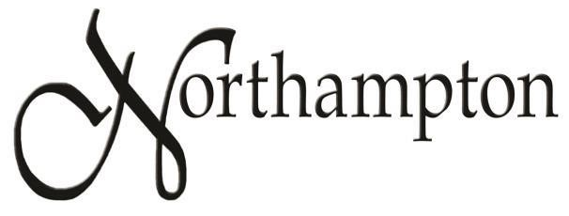

Homeowner’s Association

2021 Annual Meeting Minutes

Minutes of the annual meeting of the Northampton HOA, held Tuesday, November 9, 2021 at the Robin Ridge Clubhouse, 2325 NW 151st St, Edmond, Oklahoma.
There were 7 home owners or co-owners present, representing 5 homes. Members of the Board of Directors present were: President Chris Barkett, Vice President Maury Morris, and Board Members Chris Crane, Sandi Barkett and Mike Prykryl. The board members introduced themselves to the only other homeowner present, Mike Greene.
HOA President Chris Barkett called the meeting to order at 7:00 pm. He showed the notice of the meeting and stated that it had been mailed by first class mail to all owners of record. He asked if everyone present had received a notice and they all had. There was one proxy to be certified.

President Barkett reviewed the major happenings of 2021:
- 3 more benches were installed at the pond, bringing the total to 5 benches
- The pond was stocked with gamefish and grass carp
- The entrance signs were power washed and repainted
- Several complaints have been handled, dealing mainly with unkempt lawns and barking dogs. The City of OKC was contacted and they patched potholes and cracks in the pavement and have repaired the noisy drainage grate on 159th Terrace.
- We had three very successful neighborhood events: the Garage Sale in May, Neighbors Night Out in September, and the Halloween Party in October. The last two set new records for attendance.

Plans for the coming year were discussed:

- We are currently dealing with the entrance sign that fell out, due probably to a small earthquake or a shift in the soil. Besides replacing the concrete sign, we will have to stabilize the brick wall behind it. Experts have been contacted and quotes are being gathered.
- Plans for improving the vacant lot are continuing. We must get additional legal advice before beginning, but we will do some major landscaping.

Board member Chris Crane stated that he did not want to continue in his position after having served 3 years. He will continue as a member of the Pond Committee. There were no elections for any other positions.

(Continued on next page)
President Barkett opened the meeting for discussion of other topics:

- There is a concern for drivers speeding through the neighborhood. The city will not install speed bumps.
- Quite a few people are neglecting their yards. Some need mowing but many just have patches of tall weeds that could be easily removed. Chris Barkett and Maury Morris agreed to go around to these homes some Saturday and offer to trim them.
- To help with picking up trash around the pond, we will purchase several grabber tools for use by the Pond Committee.
- There was a discussion of the Nextdoor app. The HOA has no direct control of this app but we talked about how to change settings to make it more useful.

The meeting was adjourned at 7:34 pm.
Respectfully submitted,

Maury Morris
Vice President, Northampton HOA

PO Box 721233 | Oklahoma City, OK 73172 www.NorthamptonHOA.com

